# CERTIFICATE

This is to certify that **BIBHASINDHU PRADHAN** of class: **XII A** of **KENDRIYA VIDYALAYA BERHAMPUR** has done his project on **LIBRARY MANAGEMENT SYSTEM** under my supervision. He has taken interest and has shown at most sincerity in completion of this project.

I certify this project up to my expectation & as per guidelines issued by **CBSE, NEW DELHI.**

*Internal Examiner External Examiner*

*Principal*

# ACKNOWLEDGMENT

It is with pleasure that I acknowledge my sincere gratitude to our teacher, ***MR. SAROJ KANTA MISRA*** who taught and undertook the responsibility of teaching the subject computer science. I have been greatly benefited from his classes.

I am especially indebted to our Principal ***MR. SHIVAPRIYA DASH*** who has always been a source of encouragement and support and without whose inspiration this project would not have been a successful I would like to place on record heartfelt thanks to him.

Finally, I would like to express my sincere appreciation for all the other students for my batch their friendship & the fine time that we all shared together.

# HARDWARES AND SOFTWARES REQUIRED

**HARDWARES**

1. Desktop Computer / Laptop
2. Mobile Phone

**SOFTWARES**

* 1. Python (latest version)
  2. MySQL
  3. Python Connector Module

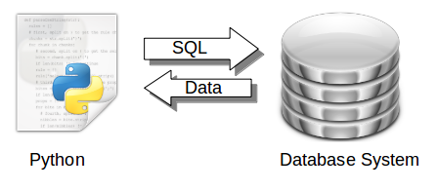

# CONTENTS

|  |  |  |
| --- | --- | --- |
| S.No. | Topic | Page No. |
| 1 | Certificate | 1 |
| 2 | Acknowledgement | 2 |
| 3 | Hardwares and Softwares Required | 3 |
| 4 | Introduction | 5 |
| 5 | Python Source Code | 6 |
| 6 | MySQL Database | 41 |
| 7 | Outputs | 44 |
| 8 | References | 52 |

# INTRODUCTION

The project **Library Management System** includes enrolment of users, adding of books into the library system. The software has the facility to search for news, wikipedia articles. It includes a authentication facility for admin and user to login into the admin panel and user panel resp. of the system. User can see the books available, details of books issued by the user in the digital library. The **Library Management System** can be login using a user ID and password. It is accessible either by an admin or user. Only the admin can add, delete and update the data of users and books into the database. The data can be retrieved easily. The interface is very user-friendly. The data are well protected for personal use and makes the data processing very fast.

The purpose of the project entitled as “DIGITAL LIBRARY” is to computerize the Front Library Management to develop software which is user friendly, simple, fast, and cost-effective. It also has a notes facility where the user can add notes at any point of the program into the database.

***Python Source Code***